Atoms into ions

Information:

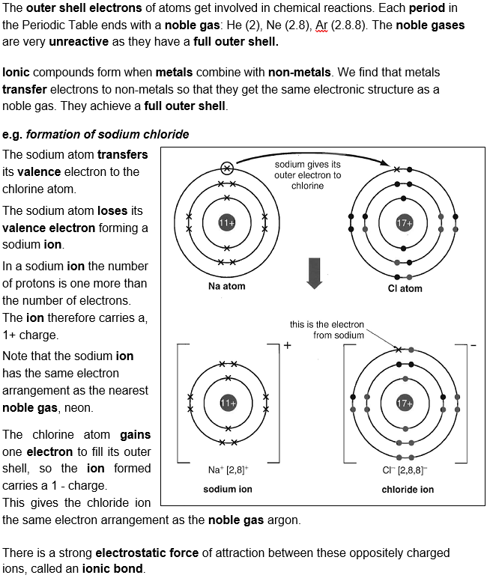

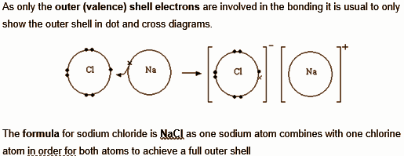

To do:
Watch this video on ionic bonding and answer the questions below:
GCSE Chemistry - Formation of Ions - Electrons | Charge | Equations
Questions:
- What is an ion?

- Why do atoms form ions?

- Why do metal atoms form into positive ions?

- Why do non metal atoms form into negative ions?

- What holds the ions together within an ionic bond?

- What is the charge on the ion formed by the atoms in the following groups:
Group Number 1 2 3 | 5 6 7

Charge on ion

- How does the group number affect the number of electrons gained or lost? (Can you find a formula linking the group number and the charge for positive ions and for negative ions?)

